CREATE JAVA APPLICATION

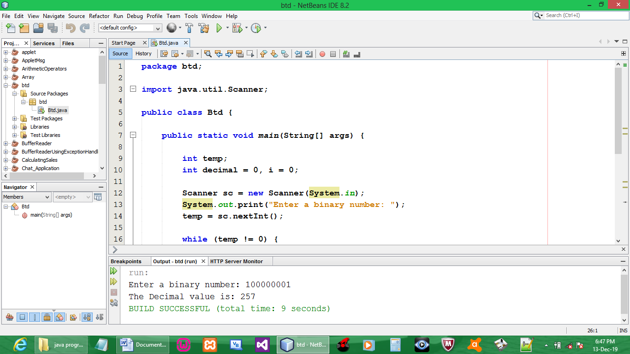

CODE:

package btd;

import java.util.Scanner;

public class Btd {

public static void main(String[] args) {

int temp;
int decimal = 0, i = 0;

Scanner sc = new Scanner(System.in);
System.out.print("Enter a binary number: ");
temp = sc.nextInt();

while (temp != 0) {
int remainder = temp % 10;
decimal = decimal + (int)(remainder * Math.pow (2, i));
i++;
temp = temp / 10;
}
System.out.print("The Decimal value is: " + decimal);
System.out.print("\n");
}
}

OUTPUT:

